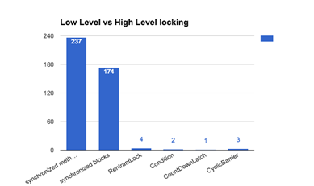

**Comparison of various high level vs low level constructs**

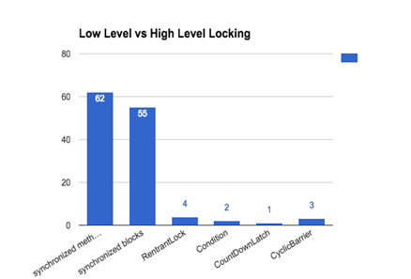

**Comparison of high level vs low level constructs without CTAG and Card Games projects**

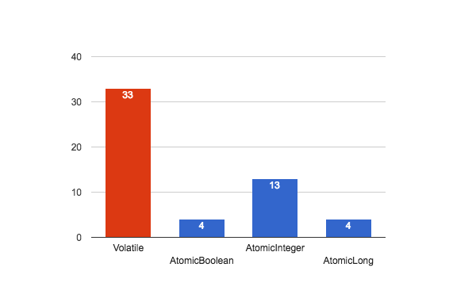

**Usage of Volatile Vs Atomic**

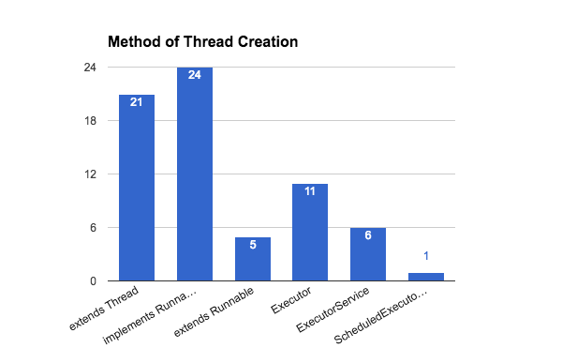

**Preferred method of Thread creation**

**Synchronized collections vs Concurrent collections**